**1.0 Objectives**

In this lab, you should be able to make a clock divider and what a clock divider is, and what it does. You should also be able to put together a clock divider circuit. The lab will also cover how to test this circuit and explore its uses.

**2.0 Parts List**

# 

| **Quantity** | **Items** | |
| --- | --- | --- |
| 2 | White 830-point Breadboard | |
| Set of | Breadboard Wire Spools | Pre-Cut Wire Kit |
| 1 | Wire Cutters Electronic Grade |
| 1 | Wire Strippers Electronic Grade |
| 1 | 2 MHz crystal oscillator ([ECS-100A-020](https://media.digikey.com/pdf/Data%20Sheets/ECS%20PDFs/ECS-100_Series.pdf)) | |
| 1 | Push Button ([TS02-66-70-BK-100-LCR-D](https://www.digikey.com/en/products/detail/same-sky-formerly-cui-devices-/TS02-66-70-BK-100-LCR-D/15634375?gclsrc=aw.ds&&utm_adgroup=&utm_source=google&utm_medium=cpc&utm_campaign=Pmax%20Shopping_Product_Passives%20Overstock&utm_term=&utm_content=&utm_id=go_cmp-21280451924_adg-_ad-__dev-c_ext-_prd-15634375_sig-Cj0KCQiA-5a9BhCBARIsACwMkJ6F4ps1_3kmZjGG0smqNkhF7Nm-4tiPpABBoxpw9auFvPX7PZAZlJ8aAnkaEALw_wcB&gad_source=1&gclid=Cj0KCQiA-5a9BhCBARIsACwMkJ6F4ps1_3kmZjGG0smqNkhF7Nm-4tiPpABBoxpw9auFvPX7PZAZlJ8aAnkaEALw_wcB&gclsrc=aw.ds)) | |
| 1 | DFF ([SN74LS377N](https://www.digikey.com/en/products/detail/texas-instruments/SN74LS377N/277309)) | |
| 1 | Dial ([NR01105ANG13](https://www.digikey.com/en/products/detail/nkk-switches/NR01105ANG13-2A/7491308)) | |
| 3 | 0.1 microF Electrolytic Capacitors | |
| 1 | 1-position DIP switch ([732-3831-5-ND](https://www.we-online.com/components/products/datasheet/418117270901.pdf)) | |
| 1 | Quad 2-to-1 MUX ([SN74HCT257N](https://www.digikey.com/en/products/detail/texas-instruments/SN74HCT257N/376803)) | |
| 1 | 5mm Red LED | |
| 3 | 1 kΩ THT Resistor | |
| 2 | 4-Bit Binary Ripple Counter ([CD74HCT93E](https://www.digikey.com/en/products/detail/texas-instruments/CD74HCT93E/38778)) | |
| 1 | Breadboard Power Supply (e.g., [YwRobot MB-V2](https://static.rapidonline.com/pdf/73-4538_v1.pdf)) | |

**3.0 Background**

In digital logic, it is an assumption that the clk signal is a given while analyzing flip flops and registers. The clock signal actually comes from a chip called a crystal oscillator, which is a circuit that uses a quartz crystal to generate a certain frequency. Then, that frequency can be divided into smaller chunks and it is displayed through an output, like an led, to show how fast or slow the frequency is. On a breadboard, some crystal oscillators may have a different pin lay out than others, despite their identical function.

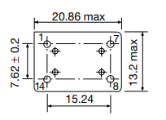

Figure 1. Crystal Oscillator view from the bottom

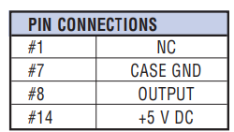

Figure 2. The pin layout showing their functions

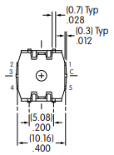

Figure 3. Dial’s orientation from the bottom-up

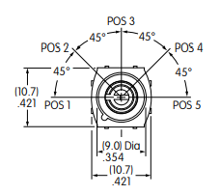

Figure 4. Dial has 5 different positions with a 180 degree orientation

**3.1 Pins**

In figure 2, it is shown that each pin number has a different function. For pin 1, NC stands for not connected so, that means the crystal does not need an enable signal. Pin 7 needs to be grounded to the bread board. Pin 8 is the output signal that will be connected to the counter’s input in order to execute the clock divider logic. Pin 14 needs to be powered by the circuit into the breadboard.

In figure 3, it is shown that the dial has five different pins, with one of them being the output. The pin labeled “c” is the output pin. In figure 4, it is shown how the dial is used the switch between different positions.

**3.2 Clock Divider Logic**

The source of the clock signal is an external crystal oscillator. The oscillator has frequencies ranging from a few KHz to hundreds of MHz along with a variety of tolerance rates. A clock divider takes an input signal and outputs a new signal with a lower frequency. A clock divider can also be called a divide-by-N where a frequency can be divided by a number N. The implementation for that is by using the counters and increment by N at each rising edge, for example. A clock divider can be useful for slowing or speeding up a logic circuit to study its behavior and to control its behavior, a dial can be used to switch between different positions.

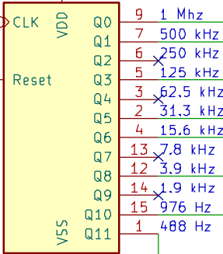

Figure 5. First 4 bit counter

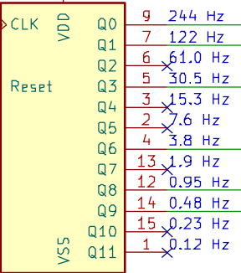

Figure 6. Second 4 bit counter

**3.3 D-Flip Flop, Counters, and MUX**

Aside from the crystal oscillator, the circuit consists of two counters, one multiplexer and one DFF. The frequency gets divided once for every two inputs into the two counters, one pin each. After that, the counters’ output to the multiplexer posing as a comparator, then the comparator is connected to the DFF to feedback into the circuit. The counters in figures 5 and 6 consist of different pins with varying frequencies. This means that the higher the frequency, the faster the output and vice versa.

**3.4 Run/Halt, Reset and Debouncing**

The reset button should toggle the comparator portion of the circuit and output a new cycle in the led. The run and halt button should manually step through the clock divider circuit instead of using the dial being used to switch to other frequencies.The R/H mechanism may be at risk for a bouncing problem. To solve this issue, a debouncing component should be incorporated into the circuit. A schmitt trigger button should solve this problem, causing a press of a button to debounce the signal.

**4.0 Clock Frequency Divider**

In this activity, you will build an analog frequency clock divider that should have a manual mode which includes using a dip switch to trigger the reset signal and using a push button to cycle through the clock signal. When the circuit is not in the manual mode, the circuit should be connected to a dial that can move to different positions to different frequencies. The desired output should be that the red led will blink slower or faster depending on where the dial is positioned.

**4.1 Place Crystal and Counters**

Start by placing the crystal oscillator, and two counters on the breadboard. Place a capacitor on each powered pin and ground each component. Then, connect the crystal oscillator to the first counter. Make a connection to both counters to each other in order for the clock signal to iterate through different frequencies provided.

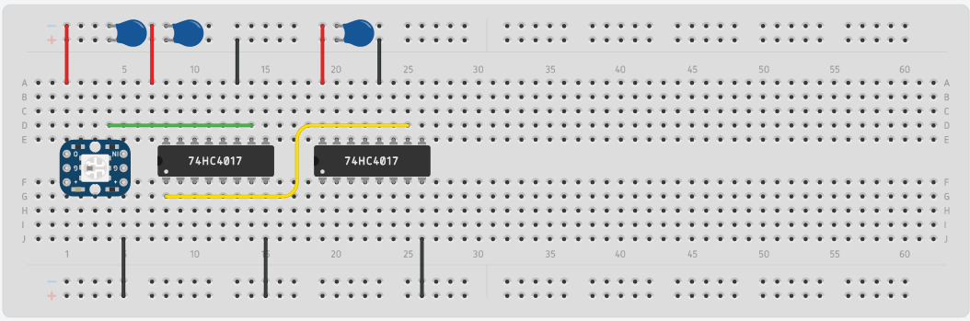

**4.2 Place Dial and Led**

Place a dial, red led, and 1k Ohm resistor on the breadboard. The dial has a control pin, which directs the signal upon a chosen position while moving the dial, and should connect to the second counter. The dial has other positions which can be connected to any pin on the counters to demonstrate the different signals the clock can output.Connect the resistor to the red led and follow the grounding protocol of the led. Connect the control pin to the led. This breadboard should work on its own while powered, showing that as the dial switches its positions, the frequency displayed through the led changes. The led should blink slower or faster, depending on the frequency of each pin in the counters.

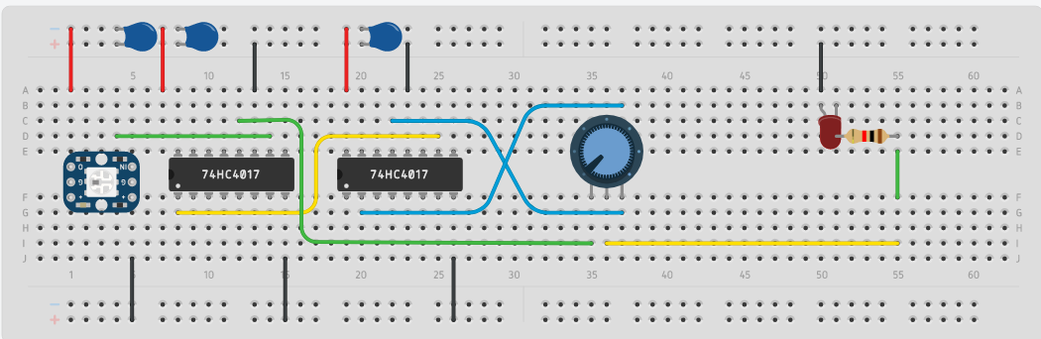

**4.3 Place DFF, MUX, DIP Switch and Button**

Place DFF, MUX, push button and DIP switch on the breadboard

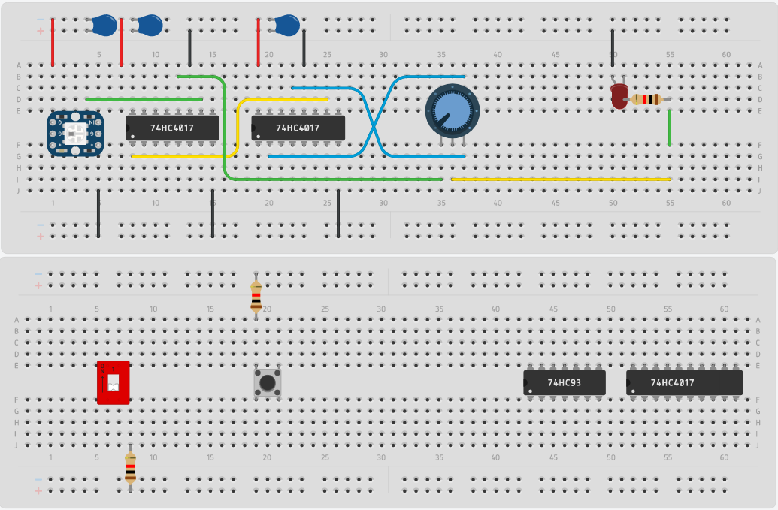

**4.4 Connecting DFF and MUX**

Connect the DFF to the MUX. Power DFF and MUX and ground their pins. Note that the DFF needs two grounds, beginning and end since the pin due to one pin acting like an enable signal needs to be grounded. Ground the push button and power its resistor. Power the dip switch and its connected resistor. Connect the Breadboards**.** Connect DFF to the dial and Clock input. Moving the dip switch from 0 to 1 should trigger a reset and pressing the button manually cycles through the clock signal.

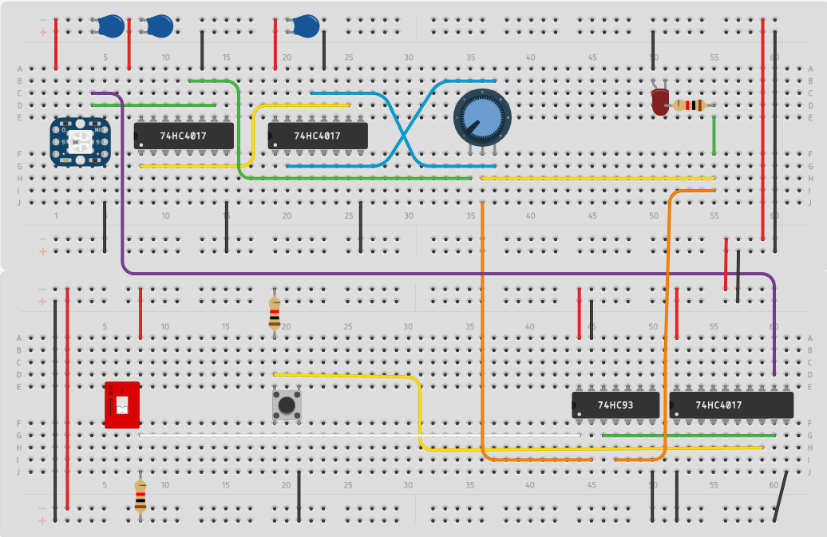

**5.0 Testing**

Power each bread board and connect them to each other. The desired output should be through the led. As the dial’s position changes, the clock frequency should either speed up or slow down. In addition, the circuit should cycle through the clock signal manually when using the dip switch and R/H mode.

